**Assignment – 10**

**Problem Statement:**

**Deploy a project from GitHub to EC2 by creating a new security group and user data.**

1. Go to EC2 and then to Security groups.

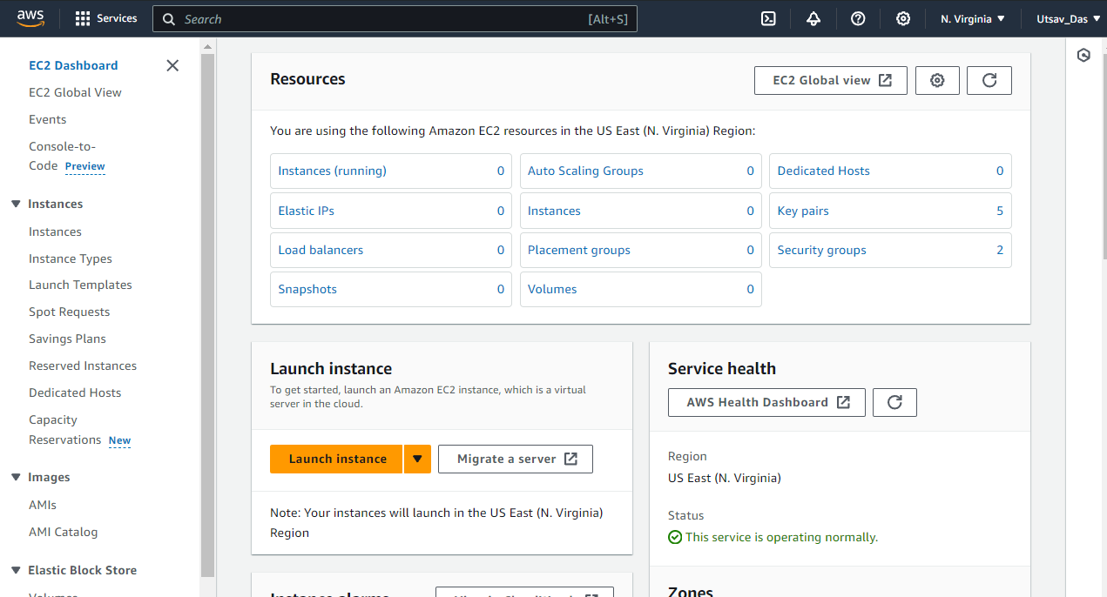

1. Click on Create Security Group option.

1. Give name of Security Group and description.

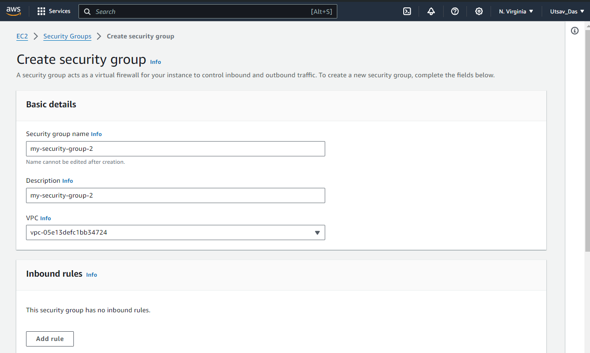

1. In Inbound rules click on Add rule. Here, we add all 4 rules: Custom TCP, SSH,

HTTP, HTTPS and in Source select 0.0.0.0/0

In port range of Custom TCP give 4000. Rest have default port number.

1. Click on Create security group.

1. Go back to instance and click on Launch instance. A screenshot of a computer

   Description automatically generated
2. Give name of instance and in Application and OS Images select Ubuntu.

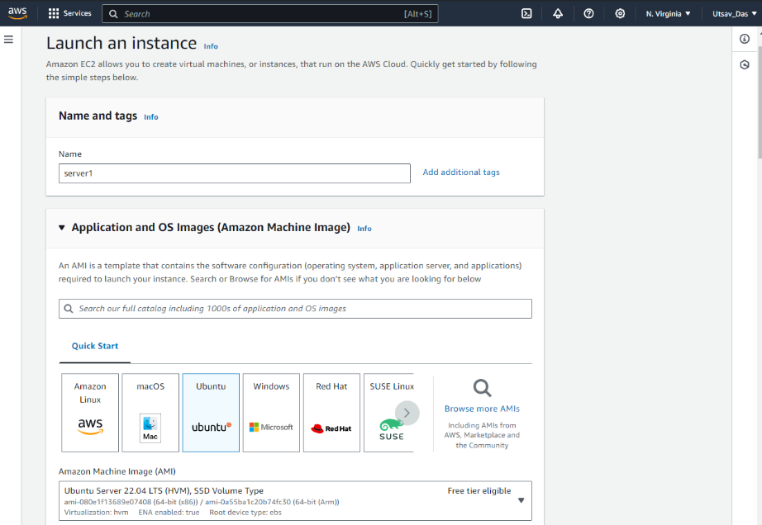

1. Click on dropdown and select existing key pair as key was already created before.

1. Click on Common Security group dropdown and select the created security group.

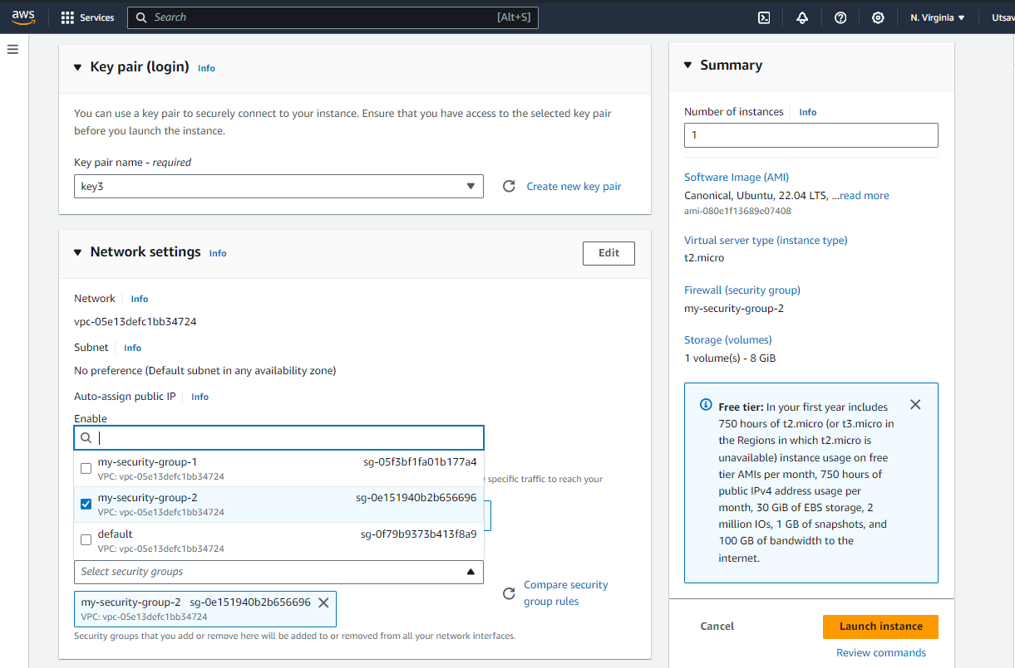

1. Go to advanced detailed section and then expand it and then go to User  
   data section and write these commands:
   * #!/bin/bash
   * apt-get update
   * apt-get install -y nginx
   * systemctl start nginx
   * systemctl enable nginx
   * apt-get install -y git
   * curl -SL https://deb.nodesource.com/setup_16.x|sudo -E bash –
   * apt-get install -y nodejs
   * git clone https://github.com/UnderDevelopment10/new-repo1.git
   * cd repo2
   * npm install
   * node index.js

After it click on Launch instance.

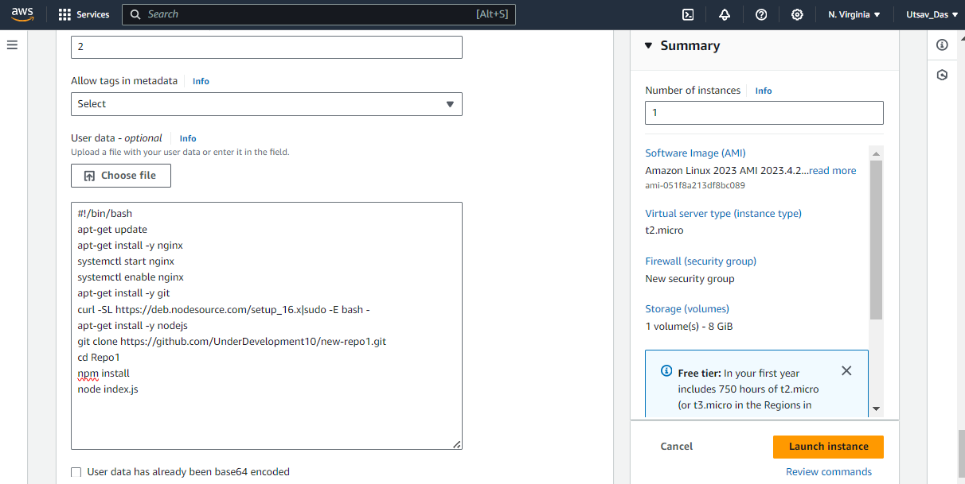

1. Go back to Instances and click on running instance. Copy the public IPv4 address.

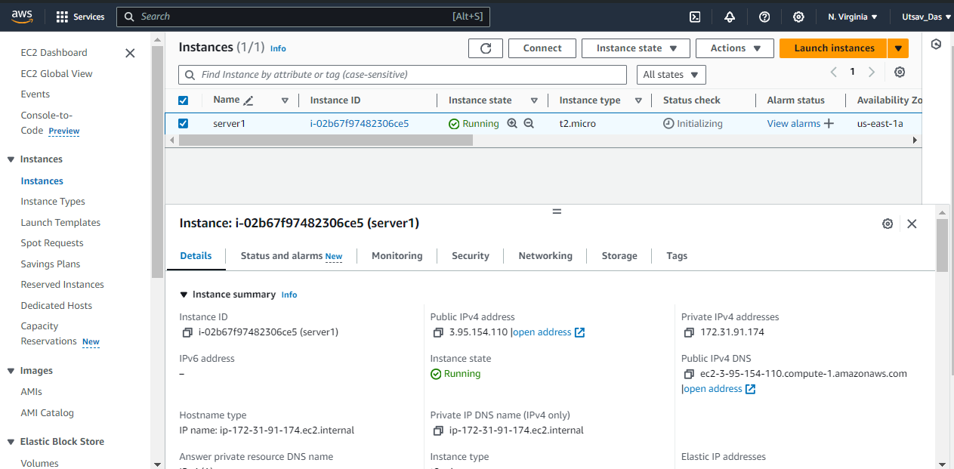

1. Paste it in another tab and enter port no. 4000 at end of URL.

